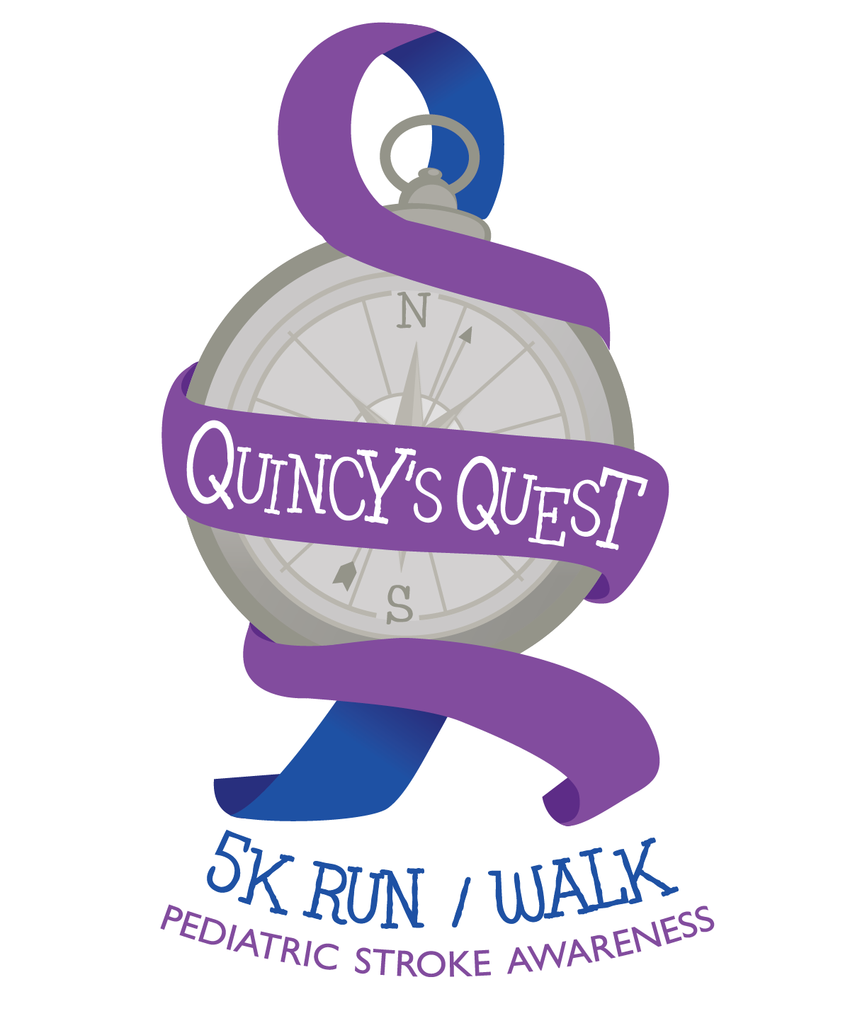

May 7, 2017

2:00 p.m.

Shawnee State Park

Schellsburg, PA

For more details and registration visit:

www.quincysquest.weebly.com

All proceeds

benefit the

**Children’s Institute**

Pittsburgh, PA

**$20**

**Individual Registration**

**$50**

**Family Registration**

**(up to 5 members in the same household)**

**$90**

**Team Registration**

**(up to 5 members)**

**Register Before**

**APRIL 26 to receive a free**

**t-shirt!**

**Registration Fee includes admission,**

**t-shirt, hydration station and after race celebration in honor of**

**Quincy’s 4th Birthday!**