Quincy’s Quest Registration Form

Name: _____________________________
Date of Birth: _____/______/_______
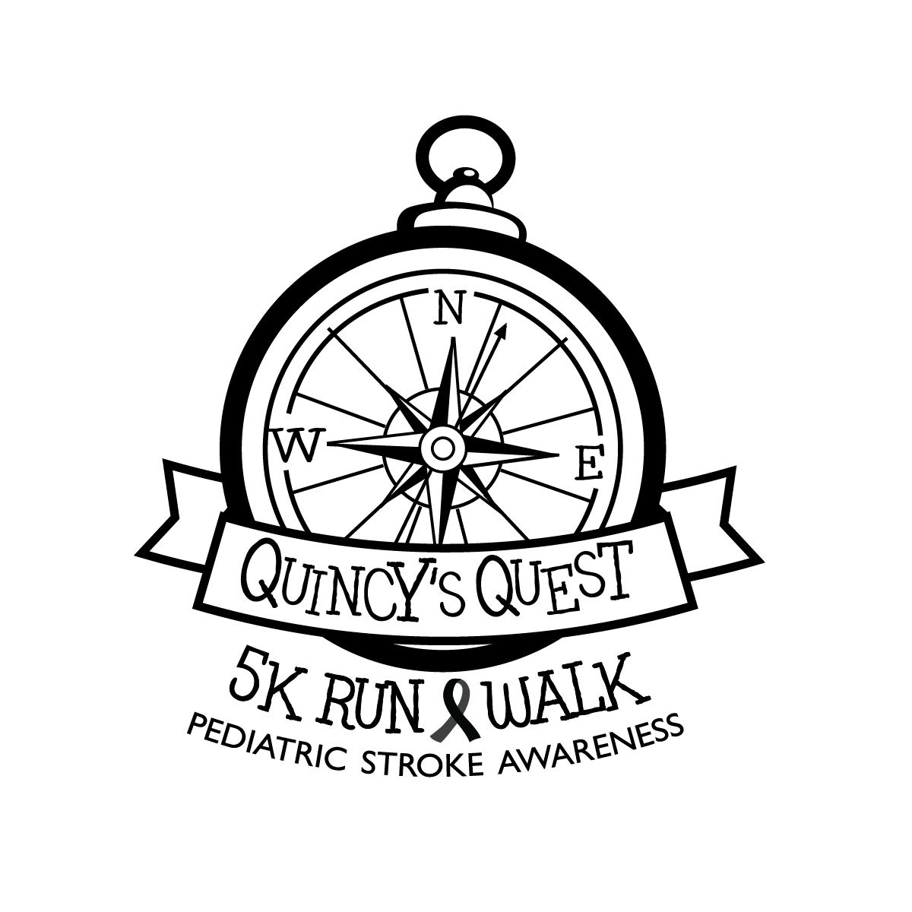
Age (Race day): ___________
Address:_________________________
City: __________________ State:______
Phone: (_____) _______-_________

T-shirt Size (circle one):
S M L XL 2XL
Youth Sizes Available by request

Race (circle one):
5K Run / Walk Team (if applicable)______________

Waiver: In submitting this entry, I, intending to be legally bound for myself, my heirs, executors, and administrators, waive, release and forever discharge the Sims, Shawnee State Park, Ronald McDonald House, CHASA, and all event sponsors, event volunteers, directors, agents, successors and/or assigns for any and all injuries suffered by me at this event. I attest that I am physically fit and prepared for this event. I understand I may be photographed and agree to allow my photo, video, or film likeness to be used for legitimate purpose by any of the aforementioned parties.
Signature: ________________________________
Parent/Guardian if under 18
Date: ______________
ALL PARTICIPANTS MUST COMPLETE A FORM
Make Checks Payable to QUINCY’S QUEST
Quincy’s Quest Registration Form

Name: _____________________________
Date of Birth: _____/______/_______
Age (Race day): ___________
Address: ___________________________
City:_________________ State:______
Phone: (_____) _______-_________

T-shirt Size (circle one):
S M L XL 2XL
Youth Sizes Available by request

Race (circle one):
5K Run / Walk Team (if applicable)_______________

Waiver: In submitting this entry, I, intending to be legally bound for myself, my heirs, executors, and administrators, waive, release and forever discharge the Sims, Shawnee State Park, Ronald McDonald House, CHASA, and all event sponsors, event volunteers, directors, agents, successors and/or assigns for any and all injuries suffered by me at this event. I attest that I am physically fit and prepared for this event. I understand I may be photographed and agree to allow my photo, video, or film likeness to be used for legitimate purpose by any of the aforementioned parties.
Signature: ________________________________
Parent/Guardian if under 18
Date: ______________
ALL PARTICIPANTS MUST COMPLETE A FORM
Make Checks Payable to QUINCY’S QUEST

